**Human Drowsiness Detection System**

**TECHNICAL FIELD OF INVENTION**

The purpose of this document is to present a detailed description of the open-source software. It will explain the purpose and features of the software, the interfaces of the software, what the software will do and the constraints under which it must operate. This document is intended for users of the software and also potential developers. It can be used by typical Users, such as IT organizations, students taking online lectures who want to use Drowsiness detection system for their users and can also be used by advanced and professional Users, such as engineers and researchers, who want to use drowsiness detection system for more analysis or fix existing bugs.

**BACKGROUND**

Drowsiness detection system is a system which will detect fatigue of the human and it will give warning. Due to drowsiness, office employees are not able to meet the deadlines of the projects allotted to them. Due to the drowsiness in offices the cost of company increases due to the delay in their projects. In this project the system will continuously monitor the eye of the human using a camera. By applying a perfect algorithm, we can detect the symptoms of drowsiness in peoples, and we will give a warning to avoid the person to get into sleep.

In this application warning will only be deactivated manually. For this a deactivation dialog box will appear which will have some basic operation for employee or we can add a device which will give an alert signal and that signal will stop only when the employee manually deactivates the signal.

Moreover, if the person is drowsy, he/she may give the wrong answer in the dialog box. We can judge this by plotting a graph in time domain. If all the three input variables show a possibility of fatigue at one moment, then a warning is given in form of text or sound. This will directly give an indication of drowsiness.

**OBJECTIVES**

1. Drowsiness detection system is an application that many organizations can use to analyse the employees. It may be used to analyse if their employees are working or suffering from any fatigue.
2. They can calculate the various data in a better way to get the detailed data about the employees working. It will tell us about the employees working time and rest time by calculations.
3. Promoting the health and well-being of individuals by preventing the negative health effects of prolonged drowsiness, such as sleep-related disorders and their associated health risks.
4. Real Time Monitoring: Continuously monitoring an individual's alertness and providing immediate feedback or alerts when drowsiness is detected.
5. Enhancing Productivity: In work environments, drowsiness detection systems can help improve productivity by ensuring that employees remain alert and focused during their tasks.

**FIGURES**

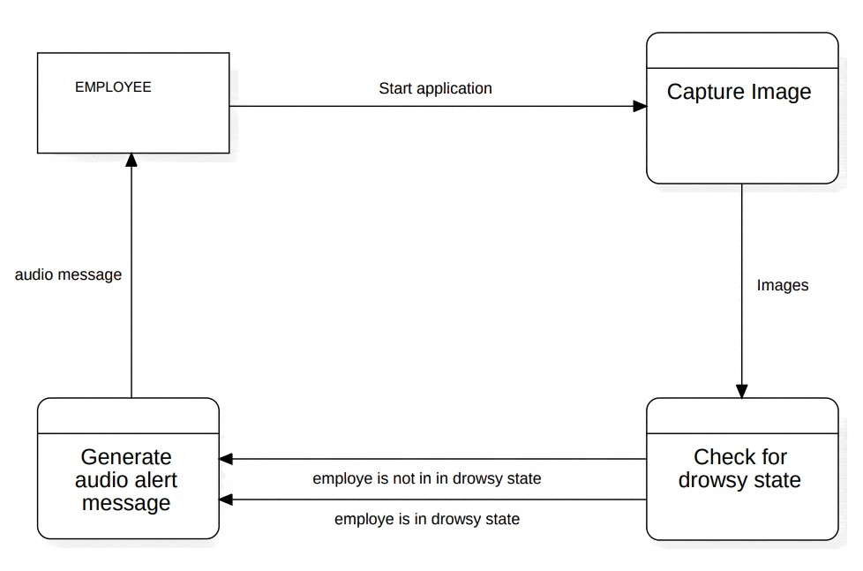

**Fig 1 . Data flow diagram**

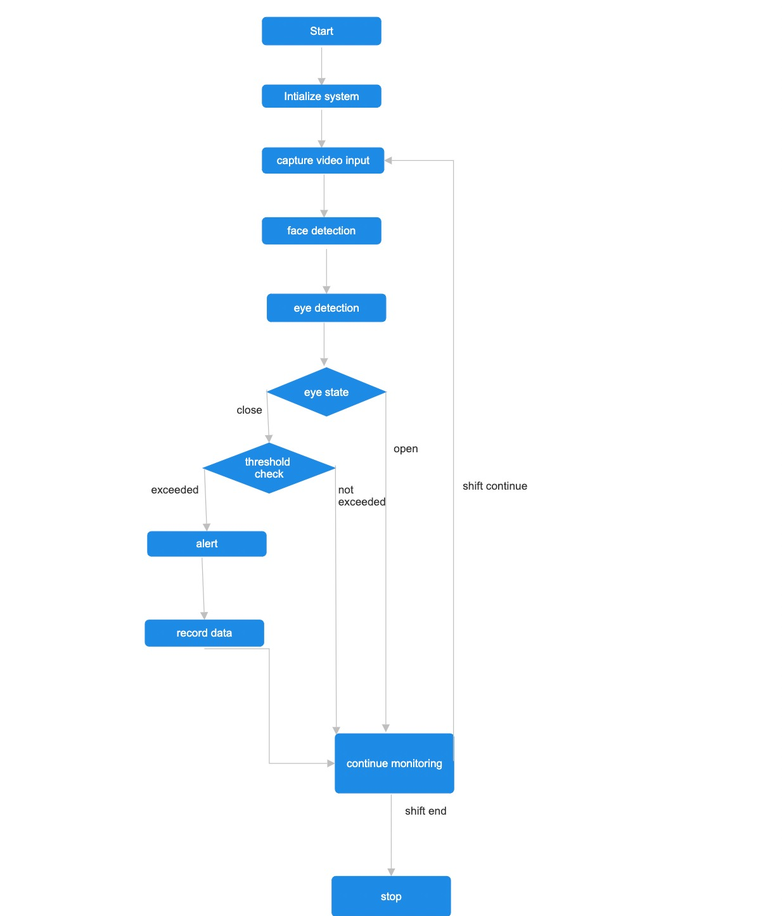

**Fig 2. Process flow digram**

**CLAIMS**

* Improved Productivity: By keeping employees alert and engaged in their tasks, the system can claim to boost overall productivity and efficiency.
* Data-Driven Insights**:** The system can provide employers with valuable data on employee drowsiness patterns. This information can be used to make data-driven decisions to improve safety and working conditions. This will lead to a new experience of technology to the user.
* Alarm functionality: The system can highlight its alarm feature, which can include audible, visual, or loud alerts to ensure employees are promptly notified when drowsiness is detected.
* 24/7 Monitoring: If applicable, the system can emphasize its ability to monitor employee drowsiness around the clock, especially in industries with shift work.

**TECHNOLOGY USED**

The technology used for drowsiness detection is based on computer vision and machine learning algorithms that can process the images captured by a webcam or a built-in camera and recognize movement of eye balls and yawning state. It uses open-source libraries like TensorFlow and OpenCV for the input and performing the calculations based on the provided input and work on bases of the machine learning algorithms. It does the recognition of eye’s state for computation. All the output are based on the given inputs and computations done by the applied algorithms.

**ABSTRACT**

The Employee drowsiness detection system will help to improve the productivity of an organization by continuously mapping the eye using the camera of the system. The user interface for the Drowsiness Detection system will consist of the following components:

1. Camera: Camera will be mounted to capture the face of the employee.
2. Indicator: The system will use indicator to provide feedback to the employee. Red light and counter value (say 15) will be the indication of drowsiness.
3. Database entry: The system will store the data of the employee in case of drowsiness.
4. User Interface: The system will have a simple and intuitive user interface for configuring and monitoring the system. It will allow the user to start and stop the system and adjust the settings.
5. Data display: The system will display data such as drowsiness level, time of detection, another alert issued on user interface.
6. Alert: the final alarm will ring to notify the drowsiness state to the person found guilty.

**REQUIRMENTS**

Performance Requirements:

The system must be able to detect drowsiness in real-time with a maximum latency of 1 second. The system must operate continuously for at least 4 hours without any performance degradation.

Safety Requirements:

The system must not distract the employee while working, and the feedback must not be too intrusive. The system must not interfere with the normal functioning of the system on which it is installed.

Security Requirements:

The system must use secure data storage and transmission protocols to protect the data collected during the working time. The system must be resistant to attacks such as tampering or spoofing of facial features.

Software Quality Attributes:

The system must be reliable and accurate in detecting drowsiness levels with a low rate of false positives and false negatives. The system must be maintainable and extensible to allow for future updates and improvements.

**END USERS**

1. Typical Users, such as IT organizations, who want to use Drowsiness detection system for their employees.
2. Advanced and professional Users, such as engineers and researchers, who want to use drowsiness detection system for more analysis.
3. Programmers who are interested in working on the project by further developing it or fix existing bugs.

**ADVANTAGES**

1. Reduction of Fatigue-related Errors**:** Drowsiness detection systems help reduce errors resulting from employee fatigue, which can be critical in industries where accuracy and precision are paramount.
2. Enhanced Shift Work Management: In industries with shift work, these systems can help employers manage and schedule shifts more effectively to minimize the impact of drowsiness during night shifts or extended working hours.
3. 24/7 Monitoring: Some systems offer continuous monitoring, ensuring employee safety during night shifts and around-the-clock operations.
4. Ergonomic benefits**:** It will directly add to more productivity of the company by maximizing the output which will increase the value of organization.

**OUTCOMES**

1. The human drowsiness detection system effectively identifies and alerts individuals to potential drowsiness episodes during different activities like online study, driving and working in IT Organizations.
2. Alert mechanism, including visual, auditory, and haptic feedback, promptly notify users upon detecting signs of drowsiness.
3. Diverse application of the system including automotive, transportation, aviation, healthcare, and workplace safety, contributing to overall safety enhancements.

**RESULT**

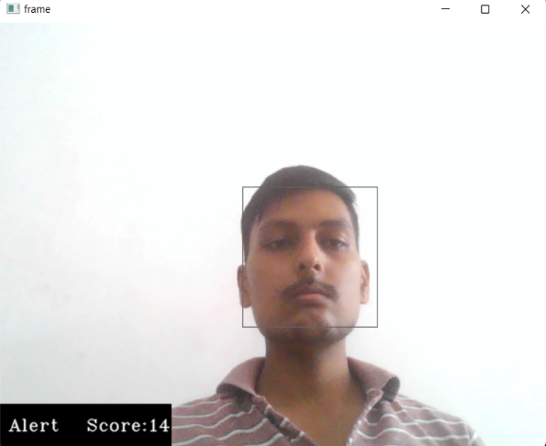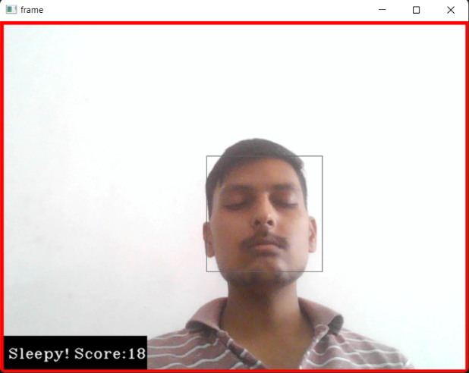

Img.1: Human in sleepy state Img.2: Human in alert state

The above images show the output result. Img.1 is the output when the human is sleepy. As the threshold value exceeds 15 it notifies about the sleepy state. Img.2 is the output image when human is not sleepy and is in alert state so there is no notification and continuous monitoring is done at this state.

**SUMMARY**

An employee drowsiness detection system is a technology-driven solution designed to enhance workplace safety and productivity. It uses various sensors, cameras, and machine learning algorithms to monitor employees for signs of drowsiness or reduced alertness. When potential fatigue is detected, the system issues real-time alerts, often in the form of alarms or notifications, prompting employees to take action to combat drowsiness. The system offers several advantages, including accident prevention, improved productivity, cost savings, compliance with regulations, data-driven insights, customizable alerts, and a focus on employee well-being. It can be tailored to different work environments and contributes to a safer, more efficient, and employee-centric workplace culture. Overall, employee drowsiness detection systems contribute to safer, more productive workplaces, reduce the risk of accidents and injuries, and prioritize the health and well-being of employees, all of which can have a positive impact on an organization's performance and reputation.

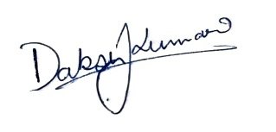**SUBMITTED BY**–

**Name:** Daksh Kumar

**Email:** daksh.singh150602@gmail.com



**Name:** Ashu Verma

**Email:** vermaashu1809@gmail.com



**Name:** Chandan Kumar Gupta

**Email:** chandangupta0811@gmail.com